Extended Abstract
Title: Explainable Deep Learning Approach for Sleep Disorder Detection and Personalized Lifestyle Recommendations
Research Summary: This work presents an AI-driven Sleep Disorder Management System that performs automated sleep staging, multi-disorder detection, interpretable reporting, and personalized recommendation. Building upon SOTA sleep staging architectures, the study systematically experiments with advanced modeling techniques and training strategies to achieve competitive performance and deployability. Since accurate staging forms the foundation for downstream clinical variable extraction, it enables medically meaningful disorder detection. To reduce black-box complexity, multiple machine learning models are evaluated for performance and inference efficiency, identifying suitable architectures for each disorder.

Objective of the study: Despite advances in automated sleep staging and disorder detection, existing approaches rely heavily on using deep neural networks with inherent black-box nature, lacking interpretability and clinical transparency[1]. Most systems focus solely on classification accuracy and do not integrate disorder management or patient interaction[2]. Furthermore, multimodal PSG-based models increase hardware complexity and inference cost[3]. This study addresses these gaps by proposing a unified end-to-end framework that integrates automated staging, multi-disorder risk prediction, explainable AI, and personalized management. The key contributions include a lightweight focused architecture, integration of clinically validated features for disorder detection, expansion toward underexplored disorders, and a clinically interpretable decision-support ecosystem.
Methodology: The proposed framework consists of automated sleep staging followed by disorder detection and management modules, as illustrated in Figure 1. The staging architecture follows a hierarchical temporal-spectral fusion design. At the epoch level, raw EEG signals are processed using adaptive atrous convolutional pyramids to capture multi-scale temporal and frequency-sensitive patterns. Squeeze-and-excitation blocks recalibrate channel responses to emphasize informative EEG components. In parallel, deterministic spectral features derived from wavelet and STFT-based transformations encode complementary frequency-domain characteristics. An attention-based fusion mechanism integrates temporal and spectral representations, generating compact embeddings for each epoch. These embeddings are then passed to a transformer encoder with positional encoding to model long-range inter-epoch dependencies and structured sleep transitions through self-attention.
For disorder detection, automated staging outputs are converted into clinically validated sleep architecture features and used to classify insomnia, sleep apnea, restless leg syndrome, and related disorders using multiple machine learning models. An explainability layer and clinical reporting module complete the end-to-end system.
Results: The proposed system was evaluated on Sleep-EDF (193 subjects) and validated using the Multi-Ethnic Study of Atherosclerosis dataset. The model achieved 79.52% accuracy for five-class sleep staging with a macro-average AUROC of 0.978 showing state-of-the-art performance in detecting N1 and REM sleep, this proves that our model is highly competitive with the SOTA models especially with the N1 stage performance which is always lowest scored due to the lack of distinctive characteristics. Apnea detection achieved an AUROC of 75.7%, insomnia 62.9%, and restless leg syndrome 62.2%.
Figure 2 presents the overall performance comparisons across staging.
Table 1 provides a comparative analysis against recent state-of-the-art models, including transformer-based sleep staging frameworks and temporal spectral fusion models. While some existing works report higher staging accuracy, the proposed system uniquely integrates lightweight design, interpretability and multi-disorder detection, and patient-facing management within a single scalable framework. This holistic integration distinguishes it from prior isolated staging or classification approaches.
Method | Per class F1 Score |  |  |  |  | Weighted Average Accuracy%
 | N1 % | N2 % | N3 % | REM % | Wake %
MultiSEss [4] | 47.62* | 83.51* | 75.36* | 75.11* | 91.58* | 82.30
ADG SleepNet [5] | 53.7 | 90.0 | 85.5 | 84.8 | 91.3 | 85.1
BiTS SleepNet [6] | 50.23 | 87.05 | 82.50 | 85.33 | 93.33 | 85.09
TSA-Net [7] | 30.11 | 84.94 | 80.02 | 81.03 | 91.71 | 82.21
Sleep Transformer [8] | 48.5 | 86.5 | 80.9 | 84.6 | 93.5 | 84.9
Temporal Spectral Cross Attention Fusion Transformer (ours) | 58.82 | 75.43 | 75.84 | 88.86 | 91.10 | 80.26
Temporal Spectral Gated Concatenation Fusion Transformer (ours) | 59.98 | 76.27 | 74.79 | 89.25 | 91.13 | 80.67
Temporal Spectral Concatenation Fusion Transformer (ours) | 59.95 | 76.54 | 76.78 | 88.9 | 91.67 | 81.04
Table I: Comparison among proposed and SOTA models. The numbers in bold indicate the best performance, and the numbers underlined are the second best. * - The paper didn’t record the per class f1 scores instead per class precision is provided thus it is incomparable to the others.
Method | Apnea Detection Performance | Insomnia Detection Performance | PLMB Detection Performance
Faust et al., 2021 | 99.80% | - | -
Sharma et al., 2022 | - | 99.70% | 97.50%
Almuhammadi et al., 2015 | 97.14% | - | -
Atianashie et al., 2021 | - | 89% | -
Ours | 75.7 (Random Forest) | 62.9 (Linear Regression) | 62.2 (SVM with RBF kernel)
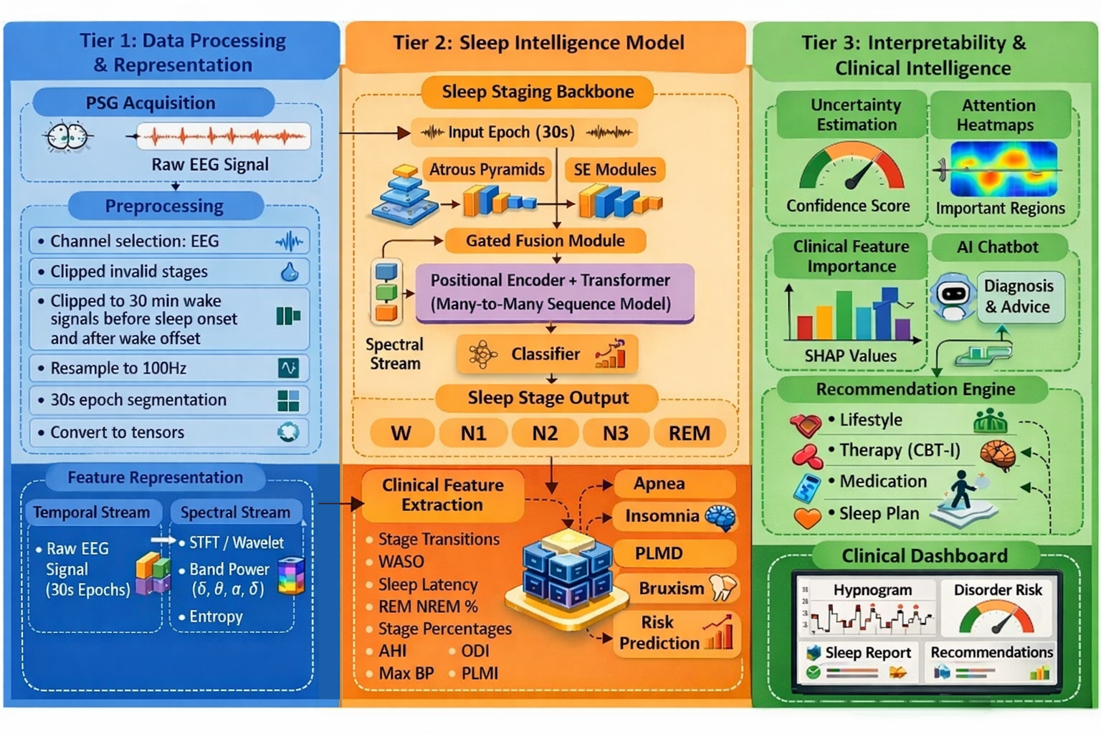Figure 1: Data flow of our proposed system, modularized into three tiers. The data uploaded by the patient will undergo processing for noise removal and better representation(on the left), further the transformed data is fed to the sleep staging backbone to sequence the sleep stages (top middle) and clinically used features are extracted from the sequence and fed to various ML classifier (bottom middle), Finally the predictions from the models are collected and various interpretable results will be represented as clinically meaningful results and provides assistive features to layman patients (on the right).
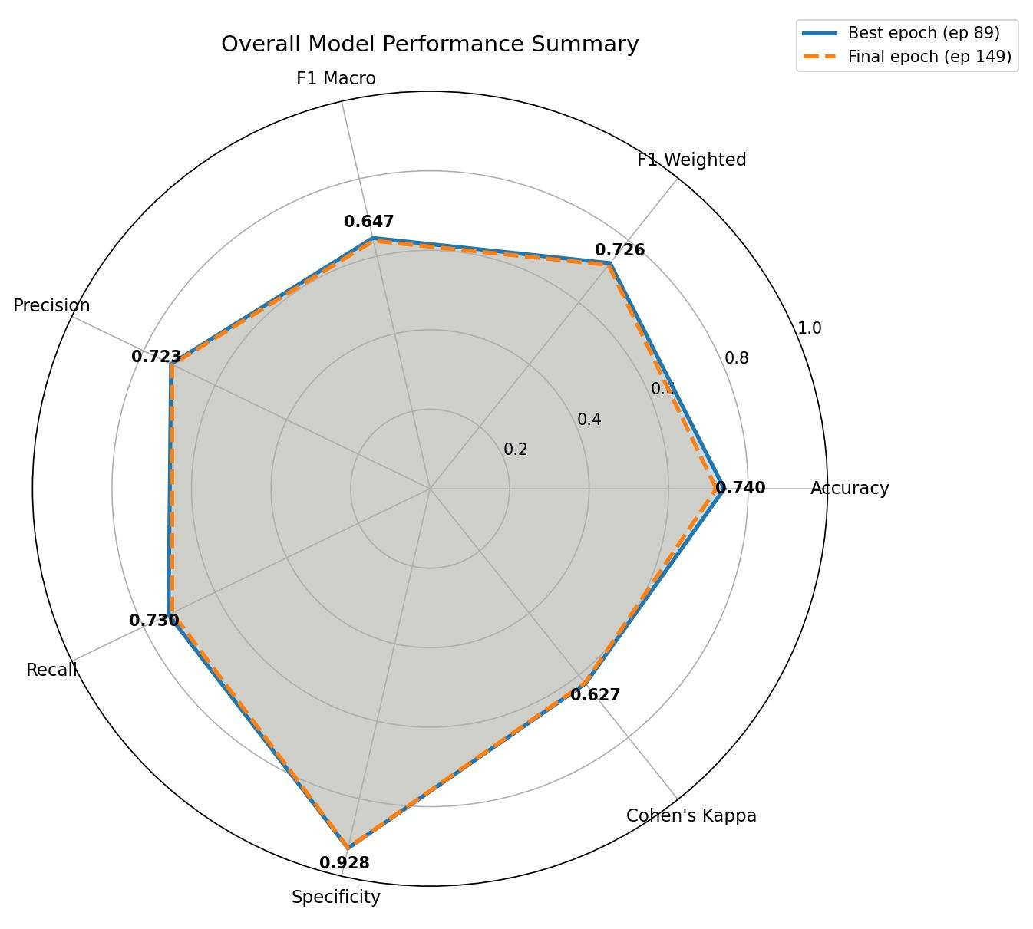
Figure 2: This figure presents the overall performance of the sleep staging backbone in various evaluation metrics which can be directly compared and benchmarked with existing SOTA models.
References
- Lee, H., Choi, Y. R., Lee, H. K., Jeong, J., Hong, J., Shin, H. W., & Kim, H. S. (2025). Explainable vision transformer for automatic visual sleep staging on multimodal PSG signals. npj Digital Medicine, 8(1), 55.
- Alattar, M., Govind, A., & Mainali, S. (2024). Artificial intelligence models for the automation of standard diagnostics in sleep medicine—a systematic review. Bioengineering, 11(3), 206.
- Xu, S., Faust, O., Seoni, S., Chakraborty, S., Barua, P. D., Loh, H. W., ... & Acharya, U. R. (2022). A review of automated sleep disorder detection. Computers in biology and medicine, 150, 106100.
- Huang, Z., Yang, Y., Wang, Z., Li, Y., Chen, Z., Ma, Y., & Zhang, S. (2025). MultiSEss: Automatic Sleep Staging Model Based on SE Attention Mechanism and State Space Model. Biomimetics, 10(5), 288.
- Sun, H., & Zhao, Z. (2025). ADG-SleepNet: A Symmetry-Aware Multi-Scale Dilation-Gated Temporal Convolutional Network with Adaptive Attention for EEG-Based Sleep Staging. Symmetry, 17(9), 1461.
- Cong, Z., Zhao, M., Gao, H., Lou, M., Zheng, G., Wang, Z., ... & Liu, C. (2024). BiTS-SleepNet: An attention-based two stage temporal-spectral fusion model for sleep staging with single-channel EEG. IEEE Journal of Biomedical and Health Informatics, 29(5), 3366-3376.
- Fu, G., Zhou, Y., Gong, P., Wang, P., Shao, W., & Zhang, D. (2023). A temporal-spectral fused and attention-based deep model for automatic sleep staging. IEEE transactions on neural systems and rehabilitation engineering, 31, 1008-1018.
- Phan, H., Mikkelsen, K., Chén, O. Y., Koch, P., Mertins, A., & De Vos, M. (2022). Sleeptransformer: Automatic sleep staging with interpretability and uncertainty quantification. IEEE Transactions on Biomedical Engineering, 69(8), 2456-2467.

Sleep stages - WASO, REM periods
Raw signals - Highest R peaks = EEG, ECG, EOG, EMG,
Hypoapnea event detection
Apnea event detection
AI HAI, AI
Naive bayes classifier, probabilistic learners, ensemble modelling

Older Versions
Motivation: Sleep is a fundamental neurophysiological process essential for metabolic regulation, cardiovascular stability, cognitive function, emotional balance, and immune health. Disruptions in sleep architecture are strongly associated with chronic diseases including cardiovascular disorders, diabetes, stroke, neurodegenerative diseases, psychiatric illnesses, and increased mortality. Epidemiological studies report that 30 to 40 percent of adults experience symptoms of insomnia, while 9 to 38 percent suffer from obstructive sleep apnea, and millions remain undiagnosed due to limited access to sleep laboratories and the social stigma surrounding sleep disorders. Untreated sleep disorders significantly impair quality of life, workplace productivity, and long-term health outcomes. The gold standard for diagnosis, polysomnography conducted under the American Academy of Sleep Medicine guidelines, requires overnight laboratory monitoring and manual scoring by trained experts. This process is time-consuming, expensive, labor-intensive, and subject to inter-scorer variability. Conventional machine learning approaches depend heavily on handcrafted features and often struggle with generalizability across datasets. Existing deep learning systems, although more powerful, frequently operate as black boxes, limiting clinical trust and adoption. There is therefore a critical need for an automated, interpretable, end-to-end deep learning framework that performs accurate sleep staging and disorder detection while also delivering clinically meaningful explanations, personalized risk assessment, and actionable guidance for patients and clinicians.
Objective: This project aims to develop a unified AI-driven Sleep Disorder Management System that integrates automated PSG-based sleep staging, multi-disorder detection including insomnia, sleep apnea, bruxism, and periodic limb movement disorder, explainable AI mechanisms for clinical interpretability, and personalized disorder management through recommendation systems and interactive assistance. Rather than focusing solely on classification performance, the system is designed as a comprehensive clinical decision-support ecosystem. It emphasizes interpretable inference, early identification of disorder patterns, and patient-centered sleep health management to bridge the gap between algorithmic predictions and practical clinical utility.
Dataset: The proposed system leverages large-scale publicly available polysomnography datasets, including Sleep-EDF with 193 subjects for sleep staging and the Multi-Ethnic Study of Atherosclerosis dataset for validation and disorder detection. The signals include EEG channels such as Fpz-Cz and C4-A1, along with ECG, EMG, EOG, respiratory signals, and oximetry. Sleep staging follows AASM standards with five classes comprising wake, N1, N2, N3, and REM. The use of multiple cohorts enables evaluation across different populations and recording conditions, supporting cross-dataset generalization and clinical relevance.
Methodology: The sleep staging model is designed to efficiently capture physiologically meaningful EEG patterns while maintaining low computational cost. Multi-scale atrous convolutional pyramids are used to extract frequency-sensitive information from EEG signals, enabling the model to analyze oscillatory activity across different temporal scales in a parameter-efficient manner. Squeeze-and-excitation mechanisms refine these representations by emphasizing the most informative components and suppressing redundant features, improving signal compactness and representation quality. By relying primarily on single-channel EEG, the system reduces hardware complexity, data acquisition burden, and inference latency compared to multimodal PSG approaches. Deterministic spectral transformations are incorporated to capture frequency-domain characteristics without requiring heavy learnable feature extractors, further reducing model cost. Long-range temporal dependencies across sleep epochs are modeled using a transformer architecture, which captures structured stage transitions while enabling interpretability through its self-attention mechanism. For disorder detection, the framework builds on clinically validated sleep architecture features derived from automated staging, ensuring interpretability and alignment with established medical knowledge. Rather than relying solely on deep neural networks inherent to complexity and black-box nature, multiple machine learning models are evaluated to achieve an appropriate balance between predictive performance and model simplicity. This design supports end-to-end automation from EEG to risk prediction and extends beyond common disorders such as insomnia and sleep apnea to explore less-studied conditions including bruxism, nocturnal frontal lobe epilepsy, and narcolepsy. An explainability layer is integrated to address the black box limitation. Attention heatmaps over time-frequency representations highlight salient signal regions, inter-epoch influence visualization illustrates contextual dependencies, and entropy-based uncertainty estimation combined with confidence calibration enables human-in-the-loop verification. Finally, a clinical management module translates predictions into structured sleep quality reports, quantifies disorder severity, generates personalized behavioral recommendations, and supports patient interaction through a conversational assistant, ensuring that model outputs extend beyond prediction into actionable guidance.
Results: Across benchmark datasets, the system achieves 67 percent accuracy for five-class sleep staging with a micro-average AUROC of 0.903. Apnea detection achieves an AUROC of 75.7 percent, insomnia detection achieves 62.9 percent AUROC, and restless leg syndrome detection achieves 62.2 percent AUROC. The framework demonstrates consistent cross-dataset performance while maintaining calibrated uncertainty estimates that allow clinicians to review low-confidence predictions, supporting safe clinical deployment.
Conclusion: We present an interpretable, multi-objective deep learning framework for automated sleep disorder management that integrates transformer-based temporal modeling, multimodal fusion, explainable attention mechanisms, and patient-centered recommendation modules. The proposed system achieves competitive performance in sleep staging and disorder detection while directly addressing critical barriers to clinical deployment including interpretability, uncertainty quantification, and personalization. By transforming polysomnography from a retrospective diagnostic procedure into a predictive, personalized, and interactive management tool, this work advances the development of scalable AI-assisted sleep medicine suitable for sleep laboratories, wearable platforms, and telemedicine environments.

Version 2
Motivation: Sleep is a fundamental neurophysiological process essential for metabolic regulation, cardiovascular stability, cognitive function, emotional balance, and immune health. Disruptions in sleep architecture are strongly associated with chronic diseases including cardiovascular disorders, diabetes, stroke, neurodegenerative diseases, psychiatric illnesses, and increased mortality. Untreated sleep disorders significantly impair quality of life, workplace productivity, and long-term health outcomes. The standard diagnosis requires overnight laboratory monitoring and manual scoring by trained experts. This process is time-consuming, expensive, labor-intensive, and subject to inter-scorer variability. Conventional machine learning approaches depend heavily on handcrafted features and often struggle with generalizability across datasets. Existing deep learning systems, although more powerful, frequently operate as black boxes, limiting clinical trust and adoption. There is therefore a critical need for an automated, interpretable, end-to-end framework that performs sleep staging and disorder detection while providing clinically meaningful explanations and actionable guidance.
Objective: This project proposes a unified AI-driven Sleep Disorder Management System that integrates automated PSG-based sleep staging, multi-disorder detection including insomnia, sleep apnea, bruxism, and periodic limb movement disorder, explainable AI mechanisms, and personalized disorder management through recommendation systems and interactive assistance. The system is designed as a comprehensive clinical decision-support platform that connects automated signal analysis with practical sleep health management.
Methodology: This work proposes a sleep staging architecture that combines multi-scale atrous convolutional pyramids for EEG feature extraction, squeeze-and-excitation mechanisms for channel-wise representation refinement, deterministic spectral feature transformation for frequency-domain encoding, and transformer-based temporal modeling for learning long-range contextual dependencies across sleep epochs. For disorder detection, automated sleep staging outputs are converted into clinically relevant sleep architecture features that are used for classification of insomnia, sleep apnea, restless leg syndrome, and additional disorders. Multiple machine learning models are implemented to perform disorder risk prediction, enabling a balance between predictive performance and interpretability. An integrated explainability layer provides attention-based visualization, uncertainty estimation, and confidence calibration. A clinical management module generates structured sleep reports, quantifies disorder severity, provides personalized recommendations, and supports patient interaction through a conversational interface.
Results: Across benchmark datasets, the system achieves 67 percent accuracy for five-class sleep staging with a micro-average AUROC of 0.903. Apnea detection achieves an AUROC of 75.7 percent, insomnia detection achieves 62.9 percent AUROC, and restless leg syndrome detection achieves 62.2 percent AUROC. The framework demonstrates cross-dataset applicability and calibrated uncertainty estimates to support clinical review.
Conclusion: We propose an interpretable, multi-objective framework for automated sleep disorder management that integrates deep learning-based sleep staging, clinical feature-driven disorder detection, explainability mechanisms, and patient-centered decision support. By connecting signal-level analysis with disorder prediction and management, this work advances the development of scalable AI-assisted sleep medicine suitable for laboratory, wearable, and telemedicine applications.

Version 3
Sleep is a fundamental neurophysiological process essential for metabolic regulation, cardiovascular stability, cognitive function, emotional balance, and immune health. Disruptions in sleep architecture are strongly associated with chronic diseases including cardiovascular disorders, diabetes, stroke, neurodegenerative diseases, psychiatric illnesses, and increased mortality. Untreated sleep disorders significantly impair quality of life, workplace productivity, and long-term health outcomes. Standard diagnosis requires overnight laboratory polysomnography and manual scoring by trained experts, a process that is time-consuming, expensive, labor-intensive, and subject to inter-scorer variability. Conventional machine learning approaches rely heavily on handcrafted features and often struggle to generalize across datasets, while existing deep learning systems, despite improved performance, frequently operate as black boxes that limit clinical trust and adoption. These limitations highlight the need for an automated, interpretable, end-to-end framework capable of performing sleep staging and disorder detection while providing clinically meaningful explanations and actionable guidance.
In this work, we propose a unified AI-driven Sleep Disorder Management System that integrates automated PSG-based sleep staging, multi-disorder detection including insomnia, sleep apnea, bruxism, and periodic limb movement disorder, explainable AI mechanisms, and personalized disorder management. The system is designed as a comprehensive clinical decision-support platform that connects signal-level analysis with practical sleep health management. The proposed sleep staging architecture combines multi-scale atrous convolutional pyramids to extract frequency-sensitive EEG representations, squeeze-and-excitation mechanisms to refine channel-wise features, deterministic spectral transformations for efficient frequency-domain encoding, and transformer-based temporal modeling to capture long-range contextual dependencies across sleep epochs. For disorder detection, outputs from automated staging are transformed into clinically relevant sleep architecture features that are used for classification of insomnia, sleep apnea, restless leg syndrome, and additional disorders. Multiple machine learning models are employed to perform disorder risk prediction, enabling a balance between predictive performance and interpretability. An integrated explainability layer provides attention-based visualization, uncertainty estimation, and confidence calibration, while a clinical management module generates structured sleep reports, quantifies disorder severity, delivers personalized recommendations, and supports patient interaction through a conversational interface.
Across benchmark datasets, the system achieves 67 percent accuracy for five-class sleep staging with a micro-average AUROC of 0.903. Apnea detection achieves an AUROC of 75.7 percent, insomnia detection achieves 62.9 percent AUROC, and restless leg syndrome detection achieves 62.2 percent AUROC. These results demonstrate cross-dataset applicability and calibrated uncertainty estimates that support clinician review. By integrating deep learning-based sleep staging, clinical feature-driven disorder detection, explainability mechanisms, and patient-centered decision support within a single framework, this work advances the development of scalable AI-assisted sleep medicine suitable for laboratory, wearable, and telemedicine environments.

Version 4
Sleep is a fundamental neurophysiological process essential for metabolic regulation, cardiovascular stability, cognitive performance, and emotional well-being. Disruptions in sleep architecture are linked to chronic diseases including cardiovascular disorders, metabolic conditions, and neuropsychiatric illnesses, while untreated sleep disorders significantly impair quality of life and productivity. Standard diagnosis relies on overnight polysomnography with manual scoring by trained experts, a process that is expensive, time-consuming, and subject to inter-scorer variability. Although machine learning and deep learning approaches have improved automation, many systems depend on handcrafted features or operate as black boxes, limiting generalizability and clinical trust.
This work proposes a unified AI-driven Sleep Disorder Management System that integrates automated sleep staging, multi-disorder detection, explainability, and patient-centered decision support within a single framework. The sleep staging architecture combines multi-scale atrous convolutional pyramids to capture frequency-sensitive EEG patterns, squeeze-and-excitation mechanisms to refine informative representations, deterministic spectral transformations for efficient frequency-domain encoding, and transformer-based temporal modeling to learn contextual dependencies across sleep epochs. The model operates primarily on EEG to reduce acquisition complexity and inference cost while preserving physiologically relevant information.
Automated staging outputs are converted into clinically validated sleep architecture features that support classification of insomnia, sleep apnea, restless leg syndrome, bruxism, and related disorders. Multiple machine learning models are evaluated to balance predictive performance with interpretability, enabling transparent risk prediction rather than opaque end-to-end decisions. An integrated explainability layer provides attention-based visualization and uncertainty estimation, while a clinical management module generates structured sleep reports and personalized recommendations.
Across benchmark datasets, the system achieves 67 percent accuracy for five-class sleep staging with a micro-average AUROC of 0.903. Apnea detection achieves an AUROC of 75.7 percent, insomnia detection 62.9 percent, and restless leg syndrome detection 62.2 percent. This framework advances scalable, interpretable AI-assisted sleep medicine for laboratory and remote care settings.

Version 5
Sleep disorders such as insomnia, sleep apnea, and restless leg syndrome are rising globally, affecting millions of individuals who remain undiagnosed or untreated. In countries like India, limited access to sleep laboratories, shortage of trained specialists, and social stigma surrounding sleep problems prevent timely intervention. As a result, a large segment of the population continues to suffer from poor sleep quality, reduced productivity, long-term health complications, and diminished quality of life. There is a clear and growing need for accessible, transparent, and scalable sleep health solutions that move beyond hospital-centered diagnosis.
This work proposes an AI-driven Sleep Disorder Management System designed to serve both clinicians and patients. The platform automates sleep staging and multi-disorder detection using EEG-based analysis, while incorporating explainable AI mechanisms that provide interpretable visualizations and structured reports. For clinicians, this reduces the black-box nature of automated systems and supports informed medical decision-making. For patients, the platform offers an interactive interface that translates complex physiological analysis into clear explanations, lifestyle recommendations, and actionable insights. By combining automated analysis with understandable feedback, the system bridges the gap between advanced medical expertise and everyday usability.
Beyond technical performance, the primary impact of this system lies in its potential to increase early diagnosis, improve public awareness of sleep health, and expand access to care through digital platforms. By enabling remote assessment, transparent reporting, and personalized guidance, the proposed solution supports preventive healthcare and empowers individuals to take control of their sleep well-being. Positioned at the intersection of artificial intelligence and digital health, this platform addresses an expanding societal need and contributes toward more equitable, accessible, and patient-centered sleep medicine.

